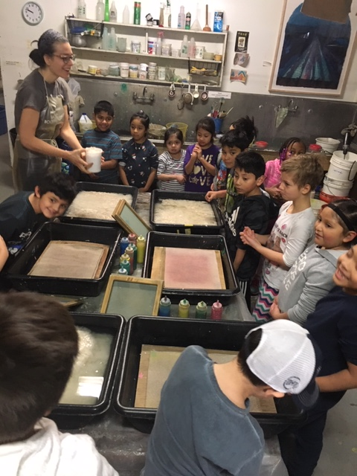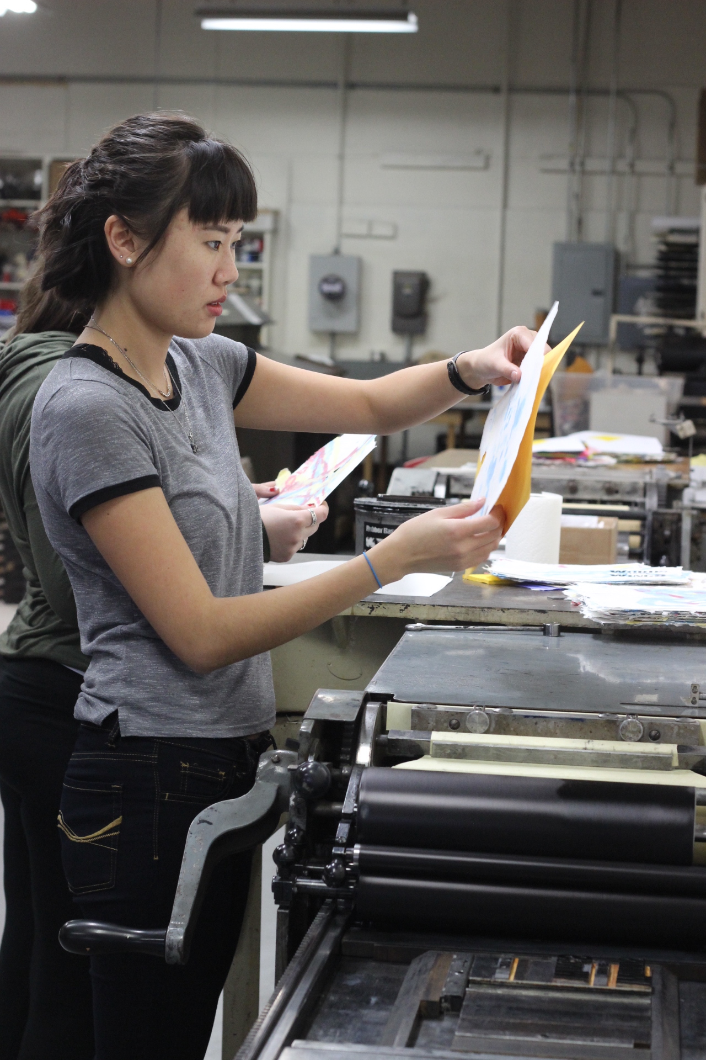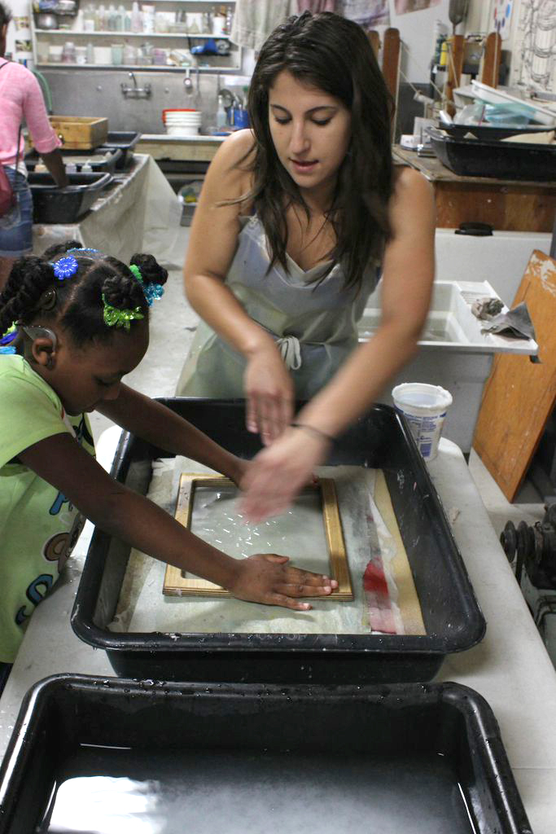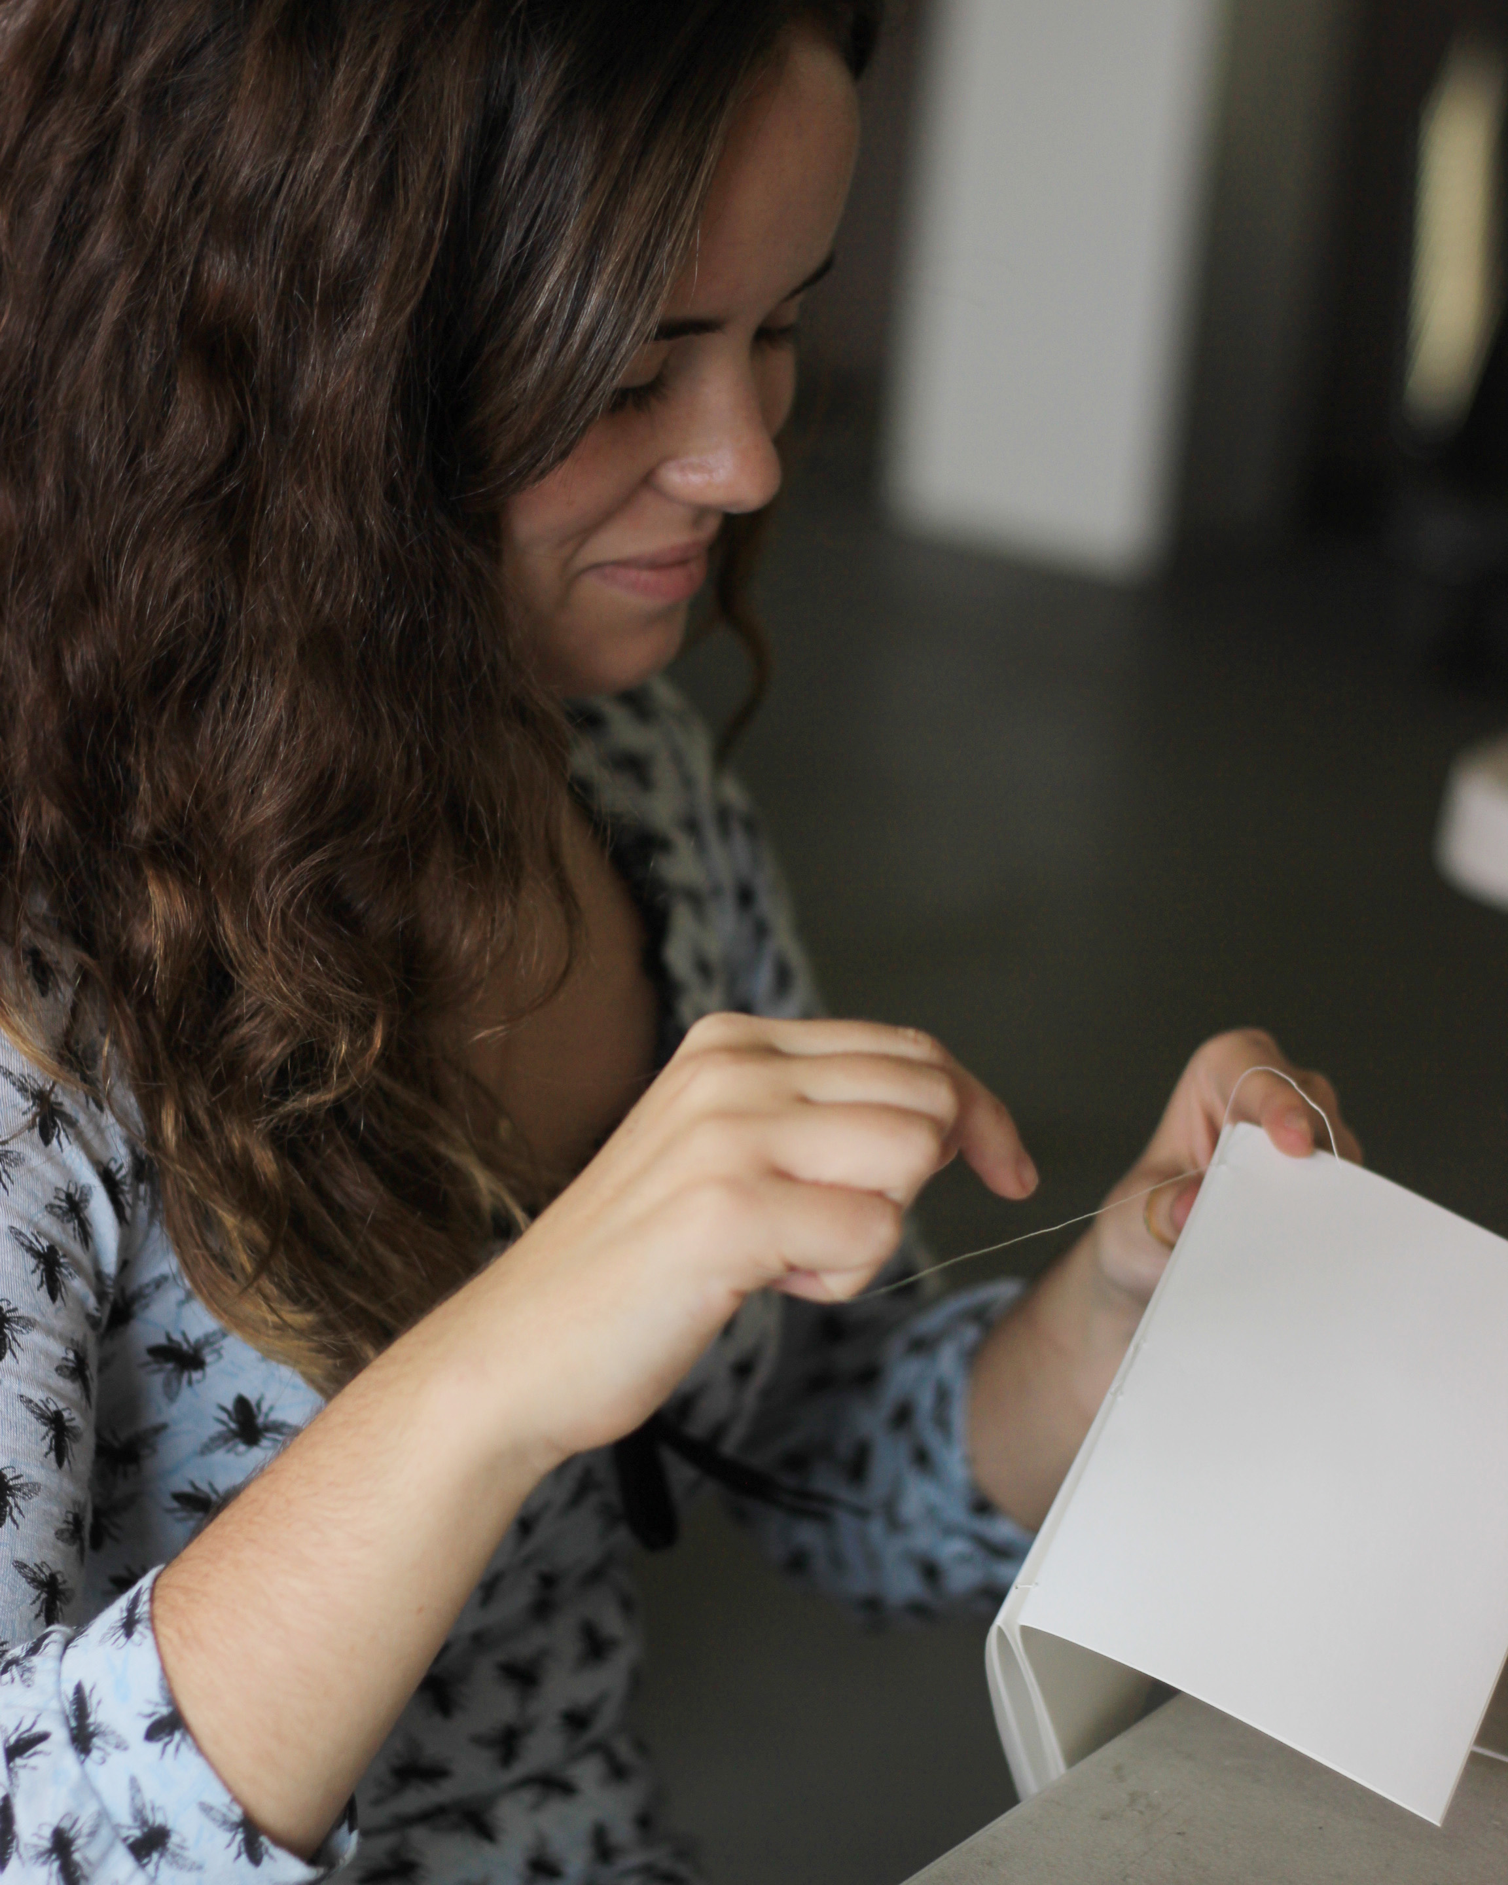

Kalamazoo Book Arts Center
326 W. Kalamazoo Ave., Suite 103A
Kalamazoo, MI 49007
269-373-4938
www.kalbookarts.org / info@kalbookarts.org

High School Internship Application
The Kalamazoo Book Arts Center accepts applications for internship positions throughout the year. Interns work under the supervision of the Director and staff to perform tasks related to the operation of the KBAC including:

- Hand papermaking, letterpress printing, bookbinding, and fine printmaking
- Production of limited-edition books, special commissions, Poets in Print broadsides, and products for the KBAC store
- Preparation of classroom materials and assistance with teaching workshops
- Gallery exhibition installation and lighting
- Publicity production, postcard and poster design, and distribution
- Administrative assignments, grant writing assistance, visitor and phone reception
- Studio maintenance, repair, cleaning, improvement, and building projects
- Special events coordination and hosting

The internship position requires 4 regularly scheduled hours at the KBAC on one day each week. The duration of an internship position is usually six weeks (during the summer) but can extend longer. To be considered for a position please send an email with the following items to info@kalbookarts.org:

- Cover letter addressing your interest in working at the KBAC
- Short resume including address, phone, email, school currently attending, and any work or volunteer experience
- 3-5 digital images of your creative work (can be in any medium)
- Beginning/ending dates desired for internship
- Weekday availability (choose one 4-hour shift during one of these days/times:
Mon., Wed., Fri., 9 a.m.–5 p.m., or Tues., 9:00 a.m.–3:00 p.m.)

